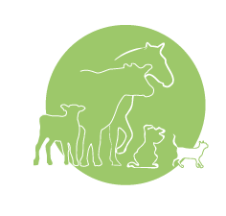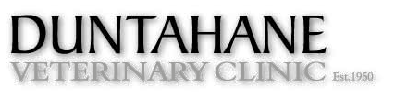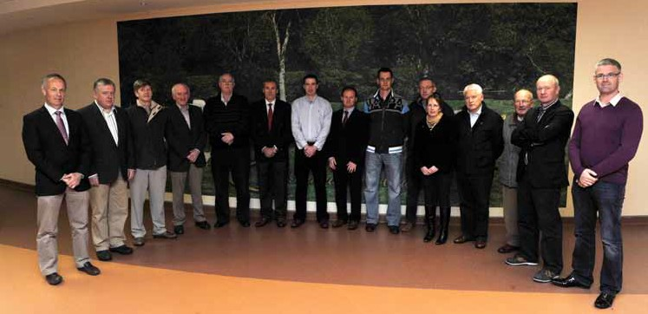Issue 8: October 2012 Tel.: 025-33060 Fax: 025-32501 E-mail: duntahanevc@eircom.net

Newsletter
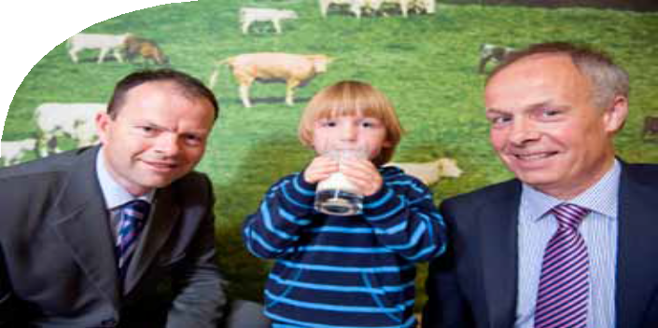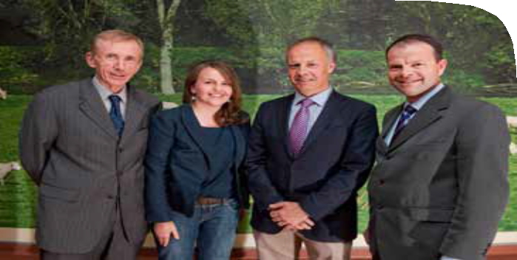w w w . dun t a h a n e v e t c lin i c . c o m

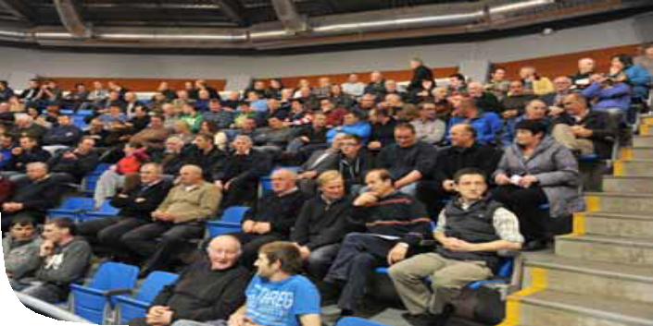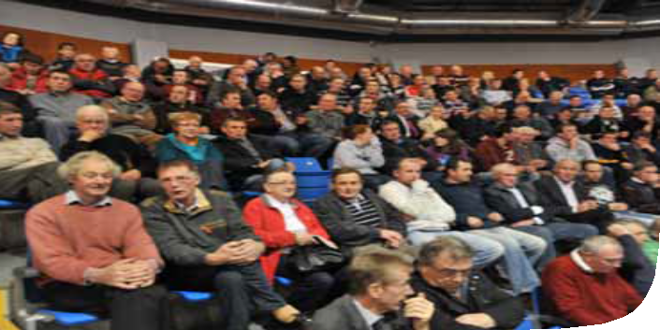Wording for this box

IBR

What is IBR and Why is it Important
IBR (infectious bovine rhinotracheitis) is a highly infectious and contagious disease caused by a Herpes virus. Seropositive cows (cows that have natural antibodies in their system against IBR) produce on average 150kg less milk each year than seronegative cows. The average cost of a case of IBR is €I34. The direct costs are associated with treatment of the sick animal, loss of milk production, abortion and possible mortality. The indirect costs are reduced weight gain, infertility and predisposition to other diseases.
IBR arrived in the late 80’s with a rising prevalence in recent years. A 2010 study reports 80% of Irish herds, both dairy and beef, are infected. Herds in Leinster were more likely to be infected than herds in Munster. Several E.U. member states have eradicated IBR. As a result they will not accept positive IBR animals from us. In addition, positive bulls will not be accepted into A.I. stations. It is likely that an eradication programme will start here in the coming years.

IBR a Farmers Perspective
A farmer with an IBR problem will have individual animals affected and it will also impact the overall disease status of the herd. Clinical signs can vary from mild to severe. Any age group can be infected however it commonly affects animals over 6 months of age.

Clinical Signs
- Short incubation period of 2 -4 days
- Fever, depression, reduced appetite
- Milk drop and discharge from the nose and eyes
- An infected animal will shed millions of infectious particles in each one ml of nasal discharge.
- This virus is quite contagious

Results of an IBR infection
- Occasionally animals may die from pneumonia if symptoms are severe
- After a week or so the animals’ immune system kicks in and usually recovers
- Once the animal recovers she develops antibodies and becomes positive (which can be detected in blood or milk samples), the IBR now becomes latent in her body.
- Infection with IBR is lifelong with all naturally infected animals becoming latent carriers. These latent carriers often show no clinical signs but periodically shed virus (often around stressful times e.g. calving or transportation) into the environment to infect uninfected animals
- Importantly in general if an animal is vaccinated against IBR and becomes infected she will not become a latent carrier.
- 3% of abortions in Ireland are due to IBR. The abortion usually occurs 2- 3 months after the initial infection.

Is my Herd at Risk from IBR?
Yes if any of the following applies:
- Purchase (buying in cows, heifers, a bull etc.)
- Herd size and density (herds with 100 or more cows are more susceptible to IBR breakdowns)
- Contact with other cattle (Shows/Sales, break out’s, break in’s, return from the mart not sold)
- Visitors (Other farmers, vets, A.I. technicians, contractors etc.)
- Equipment (shared equipment e.g. nose tongs, transport boxes, weighing scales etc.)

Diagnosis of IBR
Talk to your vet. Don’t just assume you have an IBR problem there are other diseases that can vaguely resemble IBR e.g. lung worm infestation, mycoplasma infection and liver fluke infection.
- Blood sample a group of young animals and a group of cows to check for exposure. Very occasionally latent carriers can test negative for antibodies and so testing a group of cows rather than just one cow is advisable when trying to detect exposure in a herd.
- Test the bulk milk for antibodies.
- Take nasal swabs from suspect clinical cases.
- Animals with antibodies to IBR are either naturally infected latent carriers or vaccinated animals. There is a blood test to determine which they are. It can be quite helpful with unknown stock however, be cautious it is not 100% accurate.

How do I control IBR in my Herd?
Control of IBR infection is based on farm management and biosecurity, vaccination and removal of infected animals.
- Management and Biosecurity
  - Ideally buying in and mixing of animals between herds should be avoided.
  - Purchased animals should come from known negative herds (which are rare) or be quarantined for 21 days and tested for antibodies prior to mixing with the rest of the herd.
  - Mixing of new animals into established groups should be avoided.
  - Weaning, vaccination and other interventions should be carried out prior to transportation.
  - Only negative bulls should be used for natural service as IBR virus can be shed in semen from infected bulls.

- Vaccination
Vaccination will help prevent clinical signs of IBR, viral shedding in new cases and in latent carriers and in some cases IBR abortions. Bulls that have the potential to go on to A.I. stations or for sale for breeding should not be vaccinated as these bulls will then become seropositive and prospective buyers will not want seropositive bulls. Blood tests are not 100% reliable to determine naturally infected animals from vaccinated animals. Vaccinate all in contact animals to help protect these valuable bulls.
Blood test your own stock bull and if he is seronegative he can then be vaccinated along with the rest of the herd. There are two types of vaccine live and dead (inactivated). Live vaccine works very quickly (within 4 -7 days if given intranasal and 14 - 21 days if given intramuscular). Dead vaccine is slower to work. In general live vaccine will give better protection against the clinical signs of IBR and so is often used for vaccinating young stock, weanlings, feed lot cattle and dairy cows in the face of an outbreak. Dead vaccine will decrease viral shedding in latent carrier’s thus decreasing the amount of virus in the environment ready to infect new uninfected animals. Dead vaccine is better at this than live vaccine and so is generally recommended in herds with a high number of latent carriers.
A combination of live and dead Rispoval vaccines used on the same animal can now give up to 12 months protection against viral shedding and respiratory signs of IBR. There is no data yet as to whether the animal is protected against an IBR abortion for 12 months. Herds with vaccination strategies in place should bleed a group of young stock every year to ensure there are no latent carriers being created and the vaccination programme is effective
Please discuss IBR vaccination strategies with your vet. In herds vaccinating for IBR it is advisable to vaccinate all animals in the herd (calves, maiden heifers, cows and the bull).

Vaccine | Live | Inactivated
Onset of action | 4-7 days | 14 – 21 days
Reduction of clinical signs | Yes but more effective | Yes
Reduce latent carrier shedding | Yes | Yes but more effective
- Removal of Infected Animals
Infected herds aiming to eradicate IBR need to test all animals in the herd and cull positive ones. Obviously vaccinated animals will be seropositive but a test can be used to distinguish between latent carriers with antibodies or cows with vaccination antibodies.
Culling the seropositive animals will not be practical in most herds.
Vaccination of all animals should help decrease the viral load in the environment, over time the infected animals will be
removed as they reach the end of their productive lives.
In general the young animals will not be latent carriers due to effective vaccination strategies which protect the young
animals and reduce viral shedding in the older animals.

Cost benefit of Vaccination
A full blown IBR outbreak is a very costly experience but even herds with few clinical signs that have latent carriers are not achieving their full potential. The correct vaccination protocol along with a good biosecurity programme will ensure your cows are fully protected from an outbreak. Other advantages of vaccinations which sometimes are overlooked are
  - Decrease in labour treating sick animals
  - Reduced veterinary fees
  - Increased milk production
  - Decreased risk of abortion and better herd fertility
Claire O’ Loughlin, Blackwater Vet Clinic, Mallow, Co. Cork.

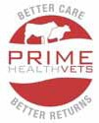Press Release

Over 400 farmers at first Prime Health Vets seminar: “Healthy Animals for Healthy Profits”
(3rd October 2012) Over 400 farmers from north and east Cork attended the first Prime Health Vets seminar in Corrin Mart, Rathcormac on 3rd October. Prime Health Vets is a new Irish alliance to enable vets provide leading edge animal health care to farmer clients.
Dr Patrick Wall, Professor of Public Health in University College Dublin’s School of Public Health and Population Sciences entertained the audience with a range of stories while driving home key points on the role of farming and farmers in the national and global food business. “You’re in the health business” he said, adding: “farmers, as the custodians of Irish livestock, are key. You are the first link in the food chain and the role of veterinary professionals is to ensure that best practice is being delivered in herd health management.” As a judge in the Irish Milk quality awards, Dr Wall is well placed to appreciate the benefits of integrated herd health and productivity plans, where the latest veterinary scientific information is tailored to each farm. These benefits not only improve
the quality of life for the farmer (and his/her animals) but also improve the farm profitability by showing that Irish animals are the best cared for in the world.
Ríona Sayers, Herd Health Research Officer with Teagasc based at Moorepark, shared seasonal tips including the importance of storing vaccinations correctly, of studying and using the analysis data on milk; and of planning work each Sunday night for the week to ensure critical tasks get done. Ríona is a leading researcher who has been to the fore in helping farmers and their vets design and implement effective controls over diseases that cost Irish farmers millions each year.
Joe O’Flaherty, CEO of Animal Health Ireland, opened the seminar and said: “BVD is known to cost Irish farmers in excess of €100 million per annum nationally. In this context, the establishment of Prime Health Vets is greatly to be welcomed, as it allows the quality of veterinary advice available to farmers to be optimised, thereby contributing to improved profitability on clients’ farms.”
Prime Health Vets has been set up by ten member veterinary practices in Munster. The aim of the group is to share knowledge, expertise and resources such that each practice’s farm clients will benefit from latest knowledge and techniques in veterinary medicine. Each veterinary practice will continue to operate as independent businesses but through PHV will optimise distribution of knowledge and expertise. As the only Irish based organisation of its kind, PHV links the unique qualities of Irish farm production with the demands of the global marketplace.

Autumnal things to do
- Scanning: Don’t assume that all bulling cows are empty. Up to 20% of pregnant cows can show standing heat. Scanning the herd also lets you plan to manage available fodder better, especially in a year where feed is at a premium.
- Silage analysis: This year has been a particularly poor one in terms of weather conditions. Silage quality will be inevitably be down on last year. Initial results from the relevant labs have confirmed this. Silage analysis for feed value, mineral analysis and interpretation are imperative this year if an optimum calving season is to be realised.
- Mastitis: bulk milk analysis- We now have the latest DNA based tests to identify the presence of the most common causes of mastitis. This is particularly useful in selecting the most effective dry cow tube for your herd.
- Fluke control: After the disastrously wet year both liver fluke and ruminal fluke are at an all time high. You may assess your herd fluke status by a bulk milk test. To diagnose rumen fluke we need a faecal sample. Please arrange to speak to one of our vets to tailor a farm specific fluke control programme.
- Parasite control: Worming for the encysted stages of Ostertagia (stomach worms) has been shown to increase yields and protein. Choosing the appropriate wormer is imperative as some of those used in the past have not been effective.
- BCS: Recording body condition score of cows is extremely important. Taking a baseline at drying off will let you plan for maximum yields next year. We can help to carry this out with you at least initially, to get most use from it long term.
- Disease control: To get the most out of your investment in vaccines, all vaccination protocols should be farm and disease specific. It is worthwhile to design this with your veterinary surgeon as part of a herd health plan. This also prevents possible conflicts between different vaccines when used together.
- Prepare calf housing: Make sure to prepare for the calving season. Check the calving jack. What condition are the ropes in?
Is the stomach tube in clean working order? Are the pens clean to allow disinfectants to work for the longest possible time?
- Target setting: As Riona Sayers made clear at the launch of PHV, make a list of jobs in order of importance and who is responsible for them. Managing your time well will make the complicated job that is farming more effective, profitable and even enjoyable!

Fermoy Print & Design 025-31355

